# PROJECT REPORT

# Traffic Light Controller

(KODA REECHA)

**AIM:**

Design and implement a traﬃc light control system for a four-lane intersection, ensuring that the duration of green lights for each direction is dynamically adjusted based on the number of vehicles present. Specifically, green lights should last 90 seconds for lanes with over 30 vehicles, 60 seconds for lanes with 20 to 30 vehicles, and 45 seconds for lanes with fewer than 20 vehicles. Additionally, if a lane has no vehicles, the green light should be transferred to another lane. Implement the following in Vivado and prepare a report for time, resource, and power analysis with the required waveform results.

**TOOLS:** Vivado 2018.2 version Software.

# THEORY:

 In the Traﬃc Light Controller Project, vehicle_count_north, vehicle_count_south, vehicle_count_west, and vehicle_count_east are 7-bit inputs representing the number of vehicles detected in each direction.

 north_light, west_light, south_light, and east_light are 2-bit outputs for the glow of the traﬃc light with respect to the count of vehicles in each state.

 clk: Clock signal.

 reset: Reset signal to initialize the system.

 for state declaration 3-bit register with variable state to hold the current state of the traﬃc lights.

 count: 7-bit register used as a timer for state transitions.

 here eight states from 000 to 111 respect to north, west, east, south, north_yellow, west_yellow, east_yellow, south_yellow.

 The state transition logic is implemented within an always block, triggered by the positive edge of the clock or reset signal.

 Each state has a corresponding handling function to manage the

vehicle counts and timer for that state.

 This Verilog module effectively manages traﬃc lights at an intersection by dynamically adjusting the light durations based on the vehicle counts in each direction. The state machine ensures that traﬃc flow is optimized, minimizing waiting times and improving overall traﬃc management.

# PROCEDURE:

 Reset the program to initialize the system. and the state becomes north .

 Set clock leading edge to 0 and falling edge to 1 for 100ns

 After make reset = 0, and enter the vehicle count data .  vehicle_count_north = 32

 vehicle_count_west = 9

 vehicle_count_south = 29

 vehicle_count_east =0

 now run the code for 10000ns and observed the wave forms.  here green_light = 3'b001(1)

 yellow_light = 3'b010(2)  red_light = 3'b100(4)

# OBSERVATION:

CASE-1: Here first start with the north state, in the north state vehicle count is 32 so the green light glows for 90 sec.

later it will go to the north_yellow state for 4 seconds later it goes to the red state. blue wave is north light.

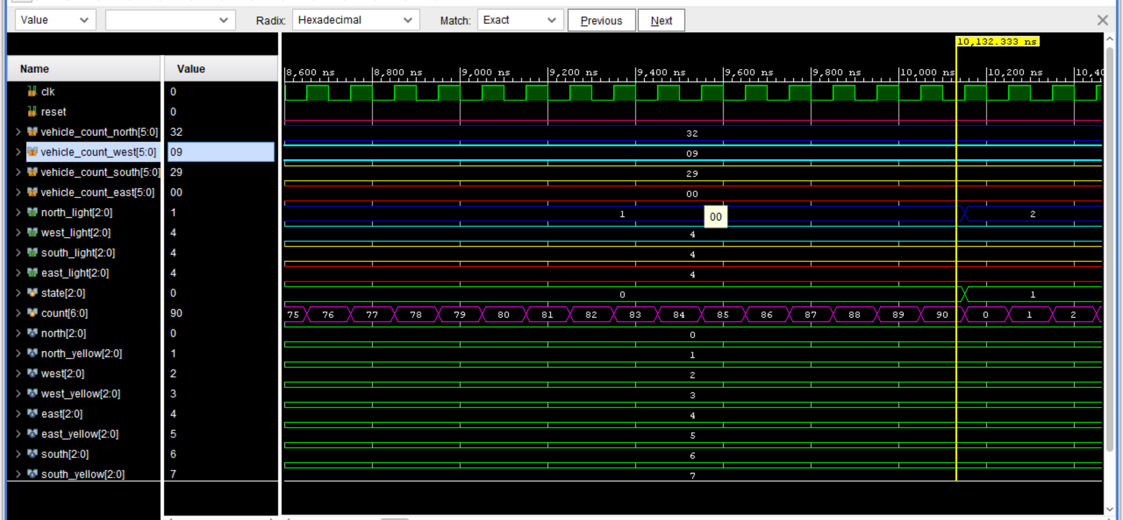

CASE-2: Here north_yellow state will run for 4 seconds

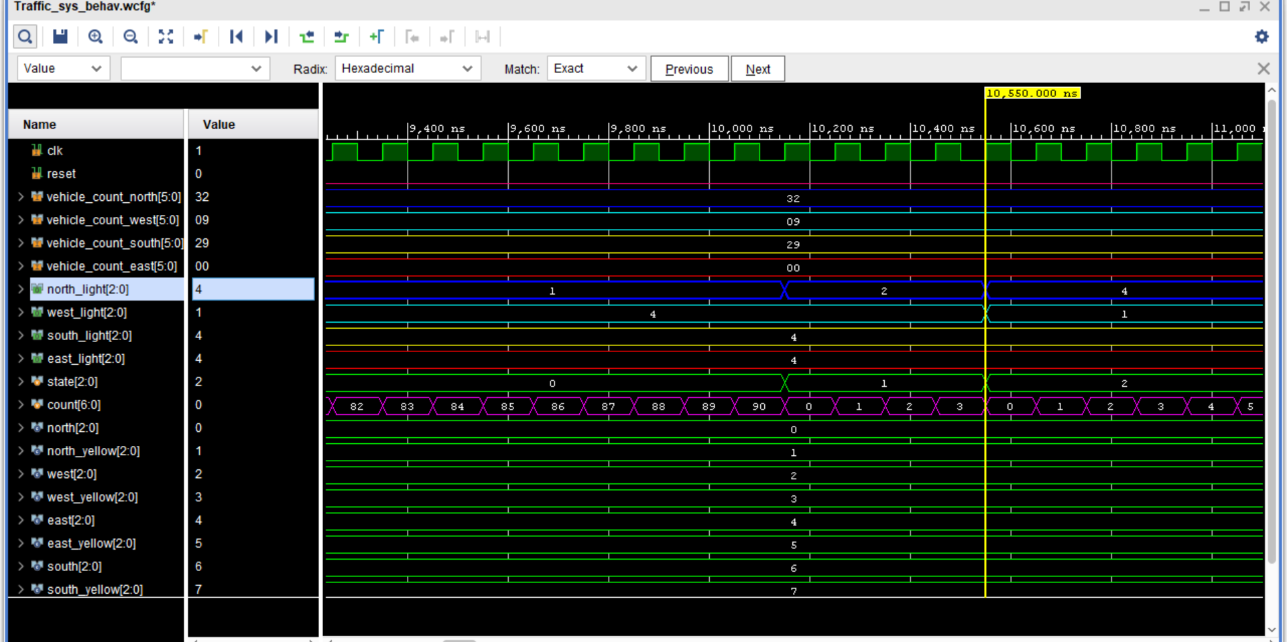

CASE-3: Now the north_yellow state goes to the west state and checks the vehicle count i.e. 09 so the green duration is 45 seconds and later it goes west_yellow state for 4 seconds and later goes red.

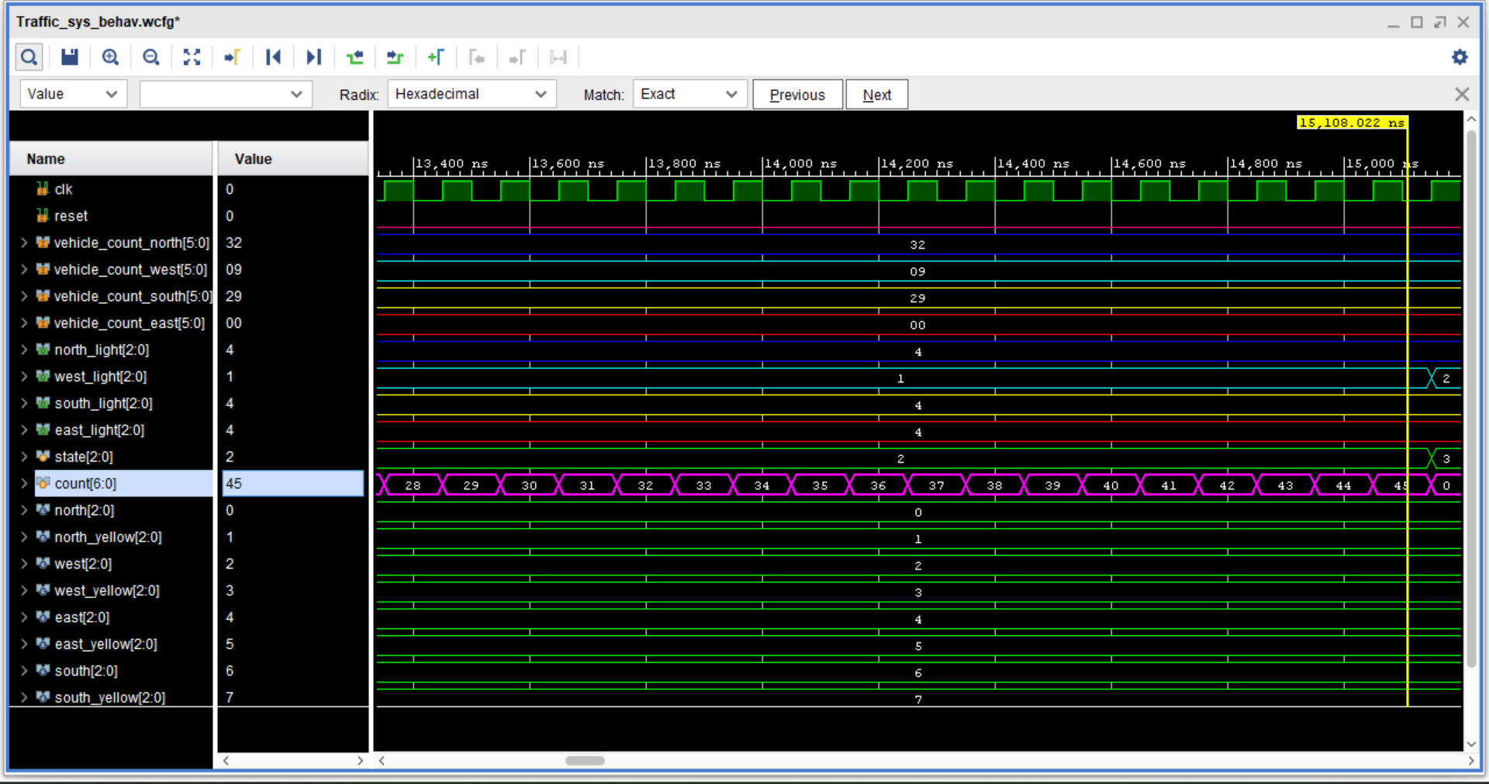

CASE-4: After west_yellow state goes to south state and checks the vehicle count i.e. 29 so the green light duration is 60 seconds and after it goes to south_yellow and yellow duration 4 seconds after that it goes to red.

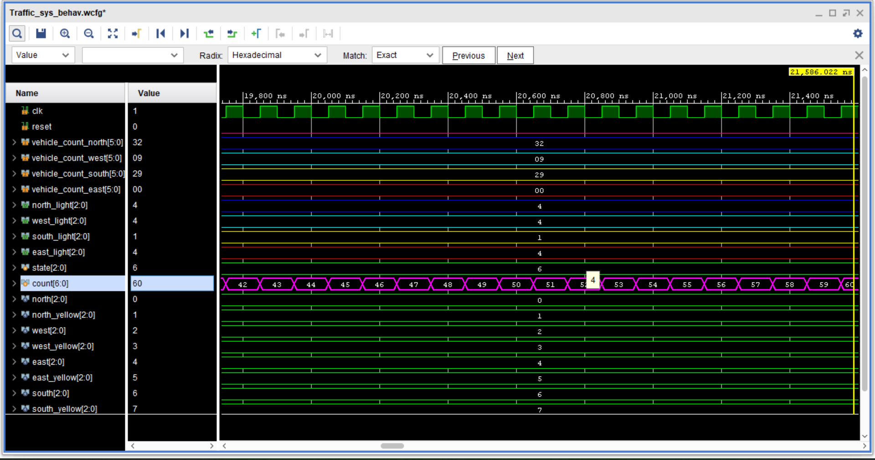

CASE-5 : From south_yellow state goes to the east and checks the vehicle count i.e. 0 so the state goes north.

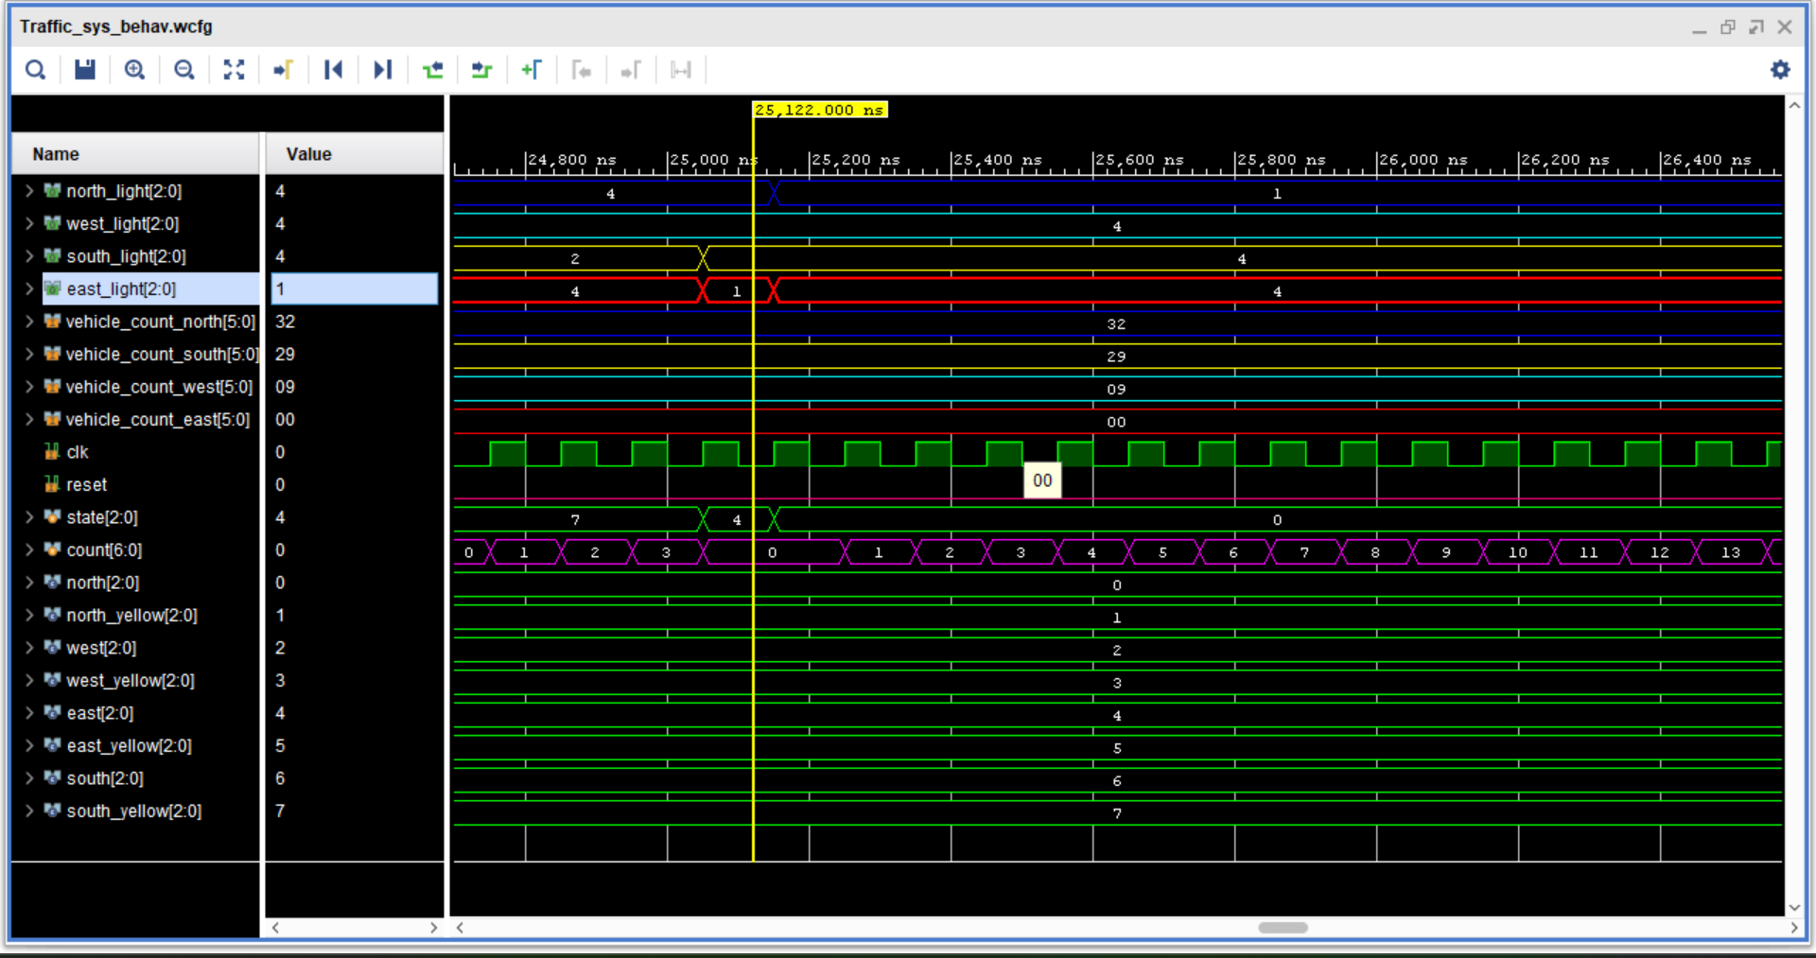

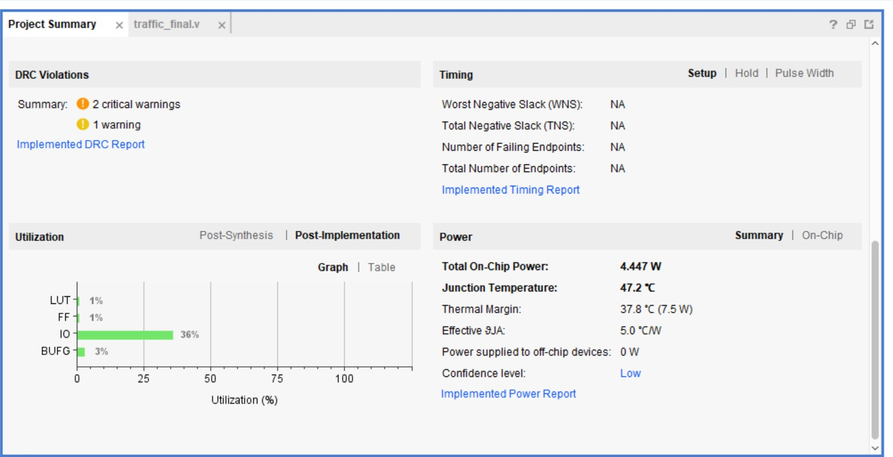 CASE-6 :Power analysis , timing.

**RESULT:**

The Verilog code for the traﬃc light control system successfully manages the traﬃc lights at a four-way intersection based on vehicle counts from each direction. The system operates as a state machine, cycling through states corresponding to green and yellow lights for the north, south, east, and west directions.

The Verilog implementation of the traﬃc light control system dynamically adjusts the traﬃc light durations based on real-time vehicle counts, ensuring eﬃcient traﬃc flow and minimizing delays at the intersection. The state machine approach provides a robust framework for managing the traﬃc lights, with clearly defined transitions and durations for each state